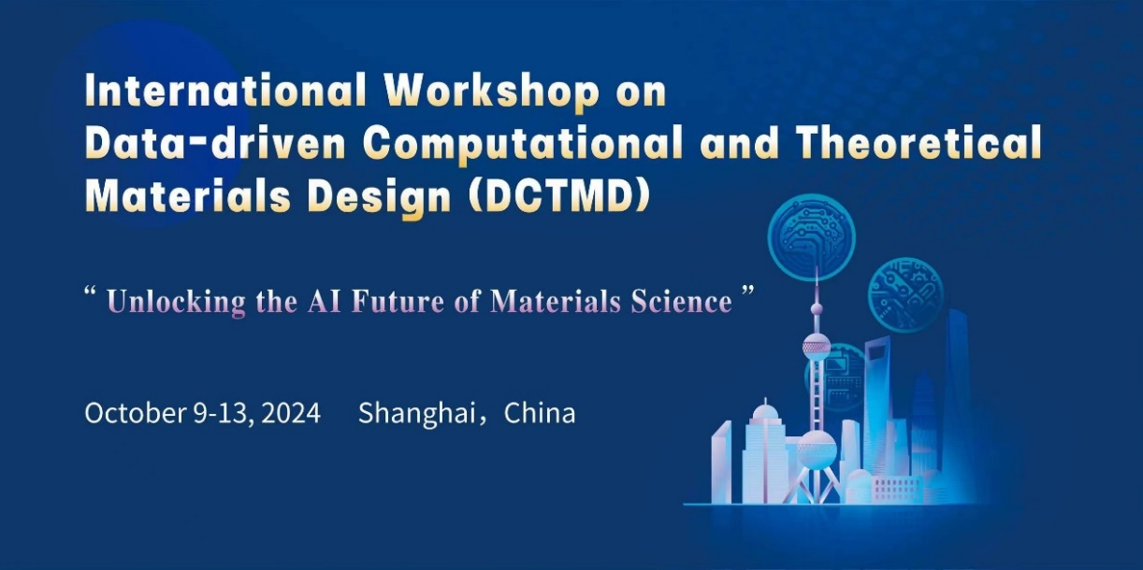

**International Workshop on Data-Driven Computational and Theoretical Materials Design (DCTMD)**

**October 9-13, 2024, Shanghai, China**

**Second-round Announcement**

Dear Colleagues and Friends,

We are thrilled to announce the upcoming International Workshop on **Data-Driven Computational and Theoretical Materials Design (DCTMD2024)**. DCTMD2024 is a premier event organized by Shanghai University, Shanghai University and the Fritz Haber (FHI) Institute in Germany, which aims to gather leading figures in the field of materials science to explore cutting-edge advances and innovations in the latest fields driven by data, computation, theory and experiment. The DCTMD conference is scheduled to be held in Shanghai from October 9-13, 2024. The relevant matters of the conference are hereby notified as follows:

1. **Date and Venue**

* **Date: October 9-13, 2024**
* **Venue:** **Grand Central Hotel Shanghai (上海大酒店)**

505 Jiujiang Road, Shanghai, China, 200001

Note: Grand Central Hotel Shanghai belongs to Shanghai Wang Baohe Hotel Group. Part of the accommodation and activities for the conference will be arranged at the Shanghai Wang Baohe Hotel.

1. **Registration and Fees**
2. **Conference Registration:**

The registration and payment for this conference will be made online and offline. Please log into the conference website <https://dctmd2024.scievent.com> to complete online registration and payment. Offline registration and payment can be completed on-site during the conference. The conference registration fee in principle does not include travel, accommodation, and meals. The related expenses will be covered by the participants themselves except for some special arrangements.

1. **Registration fees:**

|  |  |  |
| --- | --- | --- |
| Type | Faculty/staff/postdoctoral | Student |
| Early bird  (before July 1st，2024) | 2800 RMB  (380 USD) | 2200 RMB  (300 USD) |
| Regular  (After July 1st，2024) | 3500 RMB  (480 USD) | 2800 RMB  (380 USD) |

The registration fee for this conference will be collected by Guangzhou Paperclip Conference Consulting Co., Ltd. and a value-added tax electronic ordinary invoice will be issued. The invoice title is **conference fee**.

The recipient's information is as follows:

**Account Name**: Guangzhou Paper Clip Conference Consulting Co., Ltd

**Bank of Deposit**: Industrial and Commercial Bank of China Limited Guangzhou Hightech Development Zone Branch

**Bank account**: 3602176809100059737

**Please note when remitting**: DCTMD2024+name

**Contact information**: 13430355671

1. **Theme**

DCTMD2024 focuses on "**Unlocking the AI Future of Materials Science**", highlighting the transformative impact of artificial intelligence (AI), high-throughput experimental techniques, and advanced computing on materials discovery and design.The conference focused on the following topics:

[**** **Data Management and Stewardship for Materials**](https://dctmd2024.scievent.com/data-management-and-stewardship-for-materials.html)

[**** **Artificial Intelligence (AI) for Materials Design**](https://dctmd2024.scievent.com/artificial-intelligence-ai-for-materials-design.html)

[**** **AI/Autonomous/Self-Driving/Automatic Materials Lab**](https://dctmd2024.scievent.com/ai-autonomous-self-driving-automatic-materials-lab.html)

[**** **High-Throughput Computational and Experimental Materials Design**](https://dctmd2024.scievent.com/high-throughput-computational-and-experimental-materials-design.html)

[**** **Advanced Computing for Materials Design**](https://dctmd2024.scievent.com/advanced-computing-for-materials-design.html)

1. **Speakers and Abstracts**

We are honored to have a distinguished lineup of speakers who are at the forefront of their respective fields. More details about the Plenary/Invited speakers’ bios and abstracts can be found at “https://dctmd2024.scievent.com/speaker.html”.

1. **Call for Abstract**

We invite researchers, practitioners, and students to submit abstracts for oral contributed talks or posters that align with the workshop's themes. The deadline for submission of abstracts is **September 15, 2024**. For submission guidelines and more information, please visit our website. For further information, contact Dr. Runhai Ouyang via an email: DCTMD2024@163.com.

1. **Agenda**

|  |  |  |
| --- | --- | --- |
| **Date** | **Arrangement** | **Venue** |
| **October 9, 2024** | Arrive at hotel and register | Grand Central Hotel Shanghai |
| **October 10, 2024** | General Conference | Shanghai University |
| **October 11-12, 2024** | General Conference | Grand Central Hotel Shanghai |
| **October 13, 2024** | DeepMD Tutorial and Departure | Shanghai University |

For the detailed conference agenda, please visit the official website of the Conference <https://dctmd2024.scievent.com/agenda-of-dctmd.html>.

1. **Traffic Information**

The designated hotel for the conference is Shanghai Grand Hotel (505 Jiujiang Road, Shanghai, China), which is conveniently located from Shanghai Pudong International Airport, Shanghai Hongqiao Airport (train station), and Shanghai Railway Station. It is recommended to go to the conference hotel by yourself. Please refer to the conference website [https://dctmd2024.scievent.com/transportation.html](https://dctmd2024.scievent.com/transportation.htmlf) for detailed transportation routes related to the conference.

1. **Organizers**

**Workshop Chairs of DCTMD2024:**

- Matthias Scheffler (Fritz Haber Institute, Germany)

- Tong-Yi Zhang (Shanghai University, China)

**Program Organizers of DCTMD2024:**

- Matthias Scheffler (Fritz Haber Institute, Germany)

- Yi Liu (Shanghai University, China)

- Markus Buehler (Massachusetts Institute of Technology, US)

- Rika Kobayashi (Australian National University, Australia)

**Local Organizing Committee of DCTMD2024:**

* Jinchang Zhang, Lingyan Feng, Wei Ren, Junyi Ge, Yi Liu, Runhai Ouyang, Quan Qian, Zihan Wang,Jiani Sun (SHU, China)

Shanghai University

Materials Genome Institute

Aug 1st, 2024